Appendix B
Artificial Pilot Layered Architecture

Mahery ANDRIAMBOLOLONA,
Pascal LEFEUVRE,

February 18th 2003

1 Introduction 3
1.1 Flight Simulator Artificial pilot 3
1.2 Overview 3
1.3 Requirements 3
2 The Bot architecture 5
2.1 Architecture Diagram 5
2.2 Layers description 6
3 Interesting work to be done 8
4 AI LAYER Requirements 9
4.1 Overview 9
4.2 Functionalities 9
5 Conclusion 13
6 Glossary 14
7 Bibliography 15

Introduction

Flight Simulator Artificial pilot

This appendix stands directly as part of the “First proposal” report.

Overview

First, it is essential to deal with a basic analysis of the problem that is to say how the bot behavior has been modeled into several layers. It is the point of the first chapter. In the second chapter, the AI layer is specified in more details.

The Bot architecture

Architecture Diagram

The diagram below shows the bot layered architecture that has been currently defined. The thought on it is still in progress.

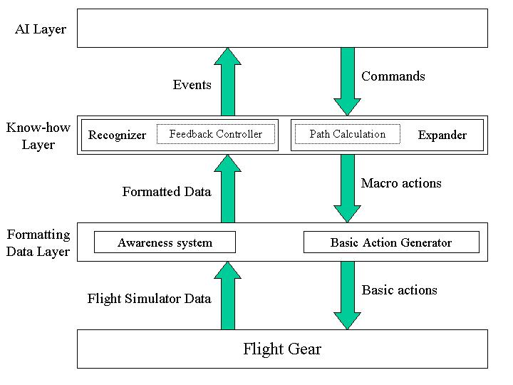
Figure 1: architecture diagram

Layers description

Now follows the description of each layer.

Formatting data layer
The aim of that layer is to translate data from the upper layers to the flight simulator and conversely.
  - The Awareness System is the system used to provide the bot with all the information of the current state of the world. It gets data directly from the flight simulator. It computes all the information gathered, to make it easier for the bot to use.
INPUT: Data from the flight simulator. They are the same as the outputs to a human player (sounds, cockpit view, instrument indications, etc…)
OUTPUT: formatted data for the upper layers (see the glossary).
  - The Basic Action Generator computes macro actions from the upper layers (ex: go from A to B with information on the route, the speed, the height, etc…) into outputs that can be interpreted by the flight simulator engine. These outputs can be compared to the inputs from a human player (keyboard, mouse, joystick).
INPUT: Macro actions from the upper layers (see the glossary)
OUTPUT: Basic actions. For instance, “press the key “b”” for a human player. (See the glossary)

Know-how layer
This layer contains all the bot’s know-how skills. These skills are used in two different ways:

- To convert the commands from the AI Layer into macro actions.
- To generate events from the information provided by the Formatting Data Layer through a recognizing process. Events characterize what is happening.

Therefore the layer is divided in two functional blocks:
  - The Recognizer takes the data coming from the Formatting Data Layer into account to assess what is happening.
INPUT: Formatted data form the Formatting Data Layer.
OUTPUT: Events (See the glossary).
  - An entity generates the macro actions required to process the commands from the AI Layer.
INPUT: Commands (See the glossary)
OUTPUT: Macro actions

To illustrate these functionalities follows an explanation on how the navigation issue is processed:
  - A Feedback Controller is a Recognizer component. It gets information from the Awareness System about the current position of the aircraft. It compares it with the expected position. If they are not the same, and if the current position is not too far from the expected one, the system suggests some corrections to do. If the current position is really far from the expected one, then the Feedback Controller send events to the AI Layer that must find a solution.
INPUT: Formatted Data from the Awareness System on the current position and features of the aircraft.
OUTPUT: data that define the difference between the expected position and the current position. These data are intended either for the AI Layer or for the Path Calculation system.
  - The Path Calculation system is an Expander component. It gives to the Basic Action Generator the route that the aircraft should follow (equations and flying parameters) and that corresponds to what the AI Layer has planned.
INPUT: a command defining the type of maneuver that the AI Layer has decided to execute (ex: a specific kind of loop).
OUTPUT: for instance a macro action that specifies the equation of a curved track, the speed, etc…

AI Layer
It represents the bot brain where the decisions are taken. It gets events that describe the situation, and then it computes the most adapted solution to face this situation. To reach this goal, a state machine and fuzzy functions are tools that can be used:

  - The State Machine represents the states in which a pilot can stand during a flight (by instance ‘taking off’, ‘landing’, ‘normal flight’, etc…). It also describes what is needed for going from one state to another one. To express how much it wants to have, the bot uses the Fuzzy Engine.
  - The Fuzzy Engine contains all the fuzzy logic rules needed to take a decision from all the information coming from the lower layers.

INPUT: Events from the Know-how Layer Recognizer.
OUTPUT: Commands

AI LAYER Requirements

Overview

All the tasks that consist of taking decisions are assigned to this layer. These decisions are more deliberative than reactive. The AI layer should be able to take several parameters into account like the available weapons, the remaining fuel etc. Many choices may be made: engaging the fight, taking evasive action etc. It is important to keep in mind that this layer is a decision-making system only.

Functionalities
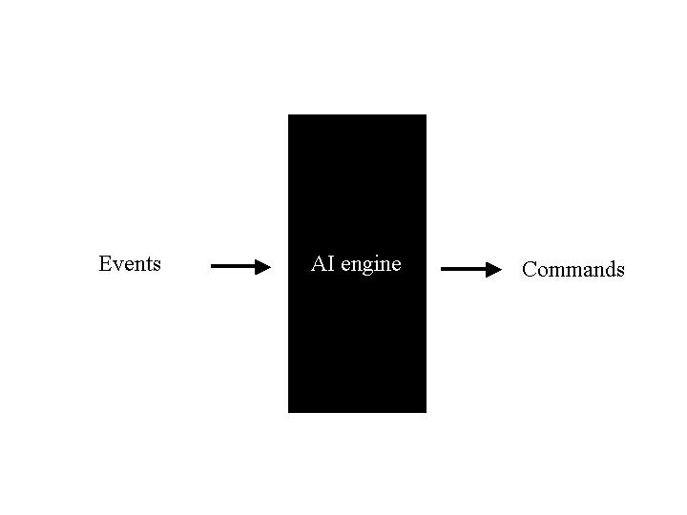
Figure 2: Input / output AI Engine

The bot intelligence is implemented in this layer. In this document Intelligence means the ability to take decisions: processing several kinds of data and adopting the most suitable behavior. As inputs, events are analyzed and as outputs commands are generated.

Providing commands
Commands | Taking decisions determines commands that have to be executed. These commands are high-level actions that do not require decisions anymore. Commands need only know-how skills to be processed. For instance, “engage the enemy” is not a command because you need to decide which kind of maneuvers you are going to perform, which weapon you should select etc. Consequently you need an intelligent process that consists in analyzing facts and making critical decisions. On the other hand, “join the tanker” is definitely a command because the only skill you need is how to proceed the refueling track.

The format of commands is not yet defined.

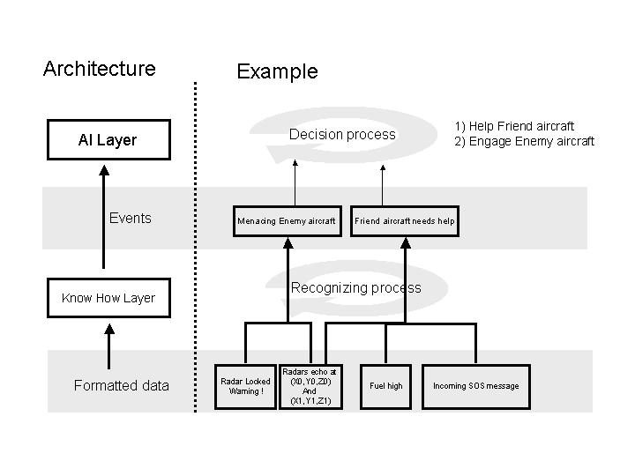
Figure 3: example of events

Getting information

Events | The AI layer gets information in the form of Events. Events are high-level data. They can be directly used by the AI Layer to generate decisions. They are dedicated to be used to generate decisions only; they do not require to be processed by any situation recognizer.  For instance “a mig-29 is near enough to engage”, “Mission target destroyed” are events. You can decide to engage an enemy that threatens you once your first priority target has been destroyed. It deals with a decision process. On the contrary, “radar warning”, “aircraft position” are not considered as events because before deciding to toggle in dogfight mode, it is useful to recognize if it is near enough to be dangerous and if it is an enemy. Yet, “radar warning, enemy position < 40 nm” can be relevant enough. It deals with a recognizing process.

They can be divided into two categories:

  - Unexpected events: there are four groups:

Enemy attack | An enemy has locked you, and has launched a missile
Aircraft failure | Your aircraft has been seriously damaged by the enemy
Physiological accident | You are experiencing physiological stresses due to G-forces.
Unexpected environmental event | Turbulences are occurring

  - Expected events: all events related to the flight plan (target destroyed, waypoint reached, runway vacated etc)

The format of events is not yet defined.

Memorizing the current situation

The bot must know the current context to take decisions. As a human pilot, a bot needs to know if it is currently fighting, taking off, or landing so that it knows what actions should be performed. Basically, each state corresponds to a short-term goal. For instance, when you dog fight, you aim to shoot the enemy down. In the taxiing from runway mode, your goal is to park your aircraft.

The bot can switch from one state to another. During a dogfight, he can decide to retreat because he has no missile left. Therefore the bot will go to “fight retreat” mode. A state diagram like the one made in chapter 3.2 of document [1] can model all these modes. Each mode is a node and you can switch from a node to another one if nodes are connected.

Here are the states:

Intermission | The bot is not in the game; it may have crashed or simply may have not yet joined the game. It will use this mode at the end of a mission.
Stand | This mode is used when the bot is typing chat messages during the game.
Starting up | The bot has switched on the main power. That is the state that follows the observer state.
Taxiing to runway | The bot is riding the airplane to the runway.
Taking off | The airplane is climbing and has exceeded the maximum taxiing speed.
Normal flight | A standard situation where the bot is flying in a friendly territory.
Dogfight | A fight with an enemy aircraft has been engaged. The bot skills are tested.
Fight Retreat: | The bot is retreating.
Taking evasive actions | The bot is taking actions to escape from a missile attack.
A-G attack | The bot is bombing a ground target.
Air refueling | The bot is joining the tanker to refuel.
Stall | A lack of energy of the aircraft.
Landing | The bot is bringing back its aircraft to ground.
Aborting the landing | The bot has started the landing procedures, and aborted it.
Flame-out Burning | An emergency landing with no engines.
Taxiing from runway | The bot is riding its aircraft to the parking.
Shutting down | The bot has switched off the main power.

Conclusion

The context in which the AI Layer operates is illustrated in the diagram below. One must be careful to the fact that this architecture is not definitive. Its goal is only to border as precisely as possible the work that will be done. This document deals more with what will be done than how it will be done. Consequently it cannot be considered as a real proposal. Some skills are currently missing to design how the AI engine will work. That is why dealing with often-used knowledge representations and reasoning systems as production systems, fuzzy systems, neural networks will be the next step so that a choice can be made.

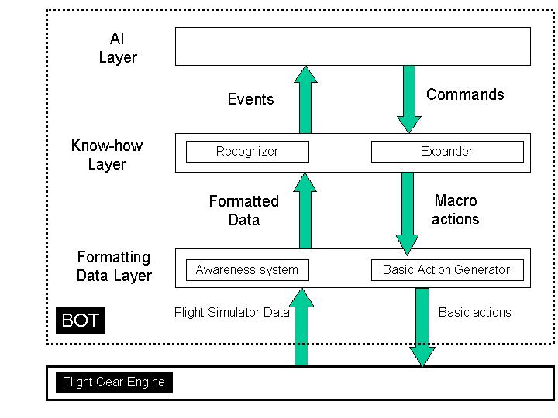
Figure 4: conclusion diagram

Glossary
Commands: AI Layer OUTPUT / Know-how Layer INPUT.
Taking decisions determines commands that have to be executed. These commands are high-level actions that do not require decisions anymore. Commands need only know-how skills to be processed.

Macro actions: Know-how Layer OUTPUT / Formatting Data Layer INPUT
It is a set of basic actions that should be performed in chronological order. The main feature of macro-actions is that they require neither decisions nor know how skills to be performed. For example, the action “use the following path defined by a sequence of (position, speed vector, altitude)” is a macro-action. The basic action generator will automatically provide the Flight Gear engine inputs (the same as a joystick and a mouse will). Otherwise, the action “start landing procedure” is not a Macro-action because, although some steps are compulsory and systematic as lowering the landing gear, decreasing the aircraft speed etc, some know how skills are required as assessing the jet trajectory.

Basic actions: Formatting Data Layer OUTPUT / Flight simulator INPUT
Atomic instructions that correspond to the same input as a mouse, a keyboard or a joystick can provide.

Flight Simulator Data: Flight simulator OUTPUT / Formatting Data Layer INPUT
Data directly provided and formatted by the Flight Simulator engine: for instance all the aircraft instruments values.

Formatted Data: Formatting Data Layer OUTPUT / Know-how Layer INPUT. To choose the appropriate behavior, the bot needs to base its reasoning on facts. The question is how to represent theses facts about the world. The sources are different: pilot health, aircraft parameters, and environment stimuli. The Bot will have its own world representation. FS engine information is processed by the awareness system so that the bot can interpret them. It could be a polygonal representation of space so that the bot can assess a trajectory avoiding collision. The way these formatted data will be is not yet defined.

Events: Know-how Layer OUTPUT / AI Layer INPUT. The AI layer gets information in the form of events. Events are high-level data. They can be directly used by the AI Layer to generate decisions. They are dedicated to be used to generate decisions only; they do not require to be processed by any situation recognizer.

